CCIIL - User Creation

Contents

1. Description 2

2. Perquisites 2

2.1. Entity 2

2.1.1. CCILUser 2

2.1.1.1. Attribute 2

2.2. Query 3

2.2.1. CCILUniqueEmail 4

2.3. Form 5

2.3.1. CCIL – User Creation 5

2.4. Email Template 5

2.4.1. Mail Body 6

3. Design 8

4. Design Form 8

4.1. Image 9

4.2. Title 9

4.3. Recipient 10

4.4. First Name 11

4.5. Last Name 13

4.6. CN 14

4.7. Email 15

4.8. MemberID 16

5. Activity 17

5.1. Start 17

5.1.1. Properties 17

5.1.2. Data Mapping 17

5.2. Entity 18

5.2.1. Properties 18

5.2.2. Data Mapping 19

5.3. Email 19

5.3.1. Properties 19

5.3.2. E-Mail Notification 19

5.4. Finish 19

5.4.1. Properties 20

1. Description:  
    CCIL user creation workflow is a user creation form which is accessible using the IDAM User Application server URL <<https://eidm.ccilindia.com/idmdash>>. In CCIL organization have many Organizations Unit (OU) & the organization Unit has admin user. Using this workflow, the OU’s admin can access this workflow and creation multiplate user on her/his Organization Unit (OU).
2. Perquisites:
   1. Entity:
      1. CCILUser  
           
         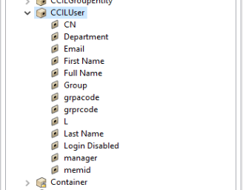
         1. Attribute:
            1. Attributes access rights**:**  
               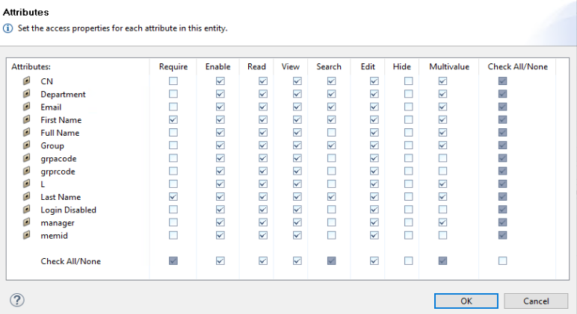
            2. Required attribute for this workflow**:**

* CN 🡪 User Common Name (Unique)
* First Name 🡪 User First Name
* Last Name 🡪 User Last Name
* Department 🡪 User Belonging OU (Unique)
* Memid 🡪 Same as Department (Unique)
* Email 🡪 User Email (Unique)
* Full Name 🡪 User Full Name.
  1. Query:
     1. CCILUniqueEmail  
        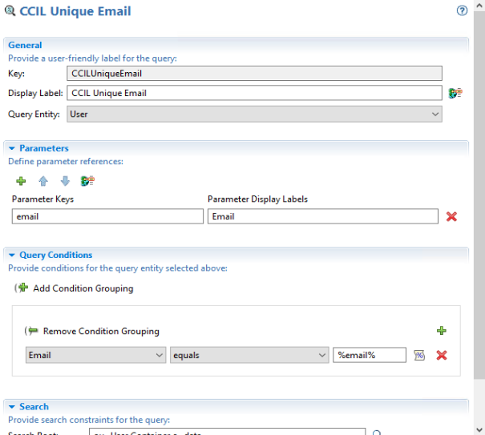  
        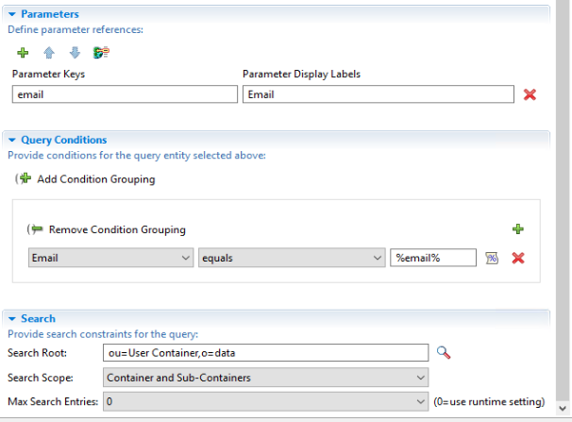
  2. Form:
     1. CCIL – User Creation   
        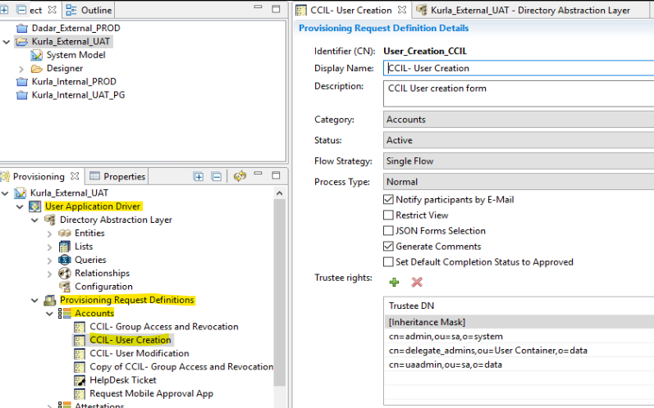
  3. Email Template:  
       
     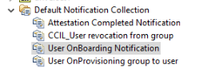  
       
     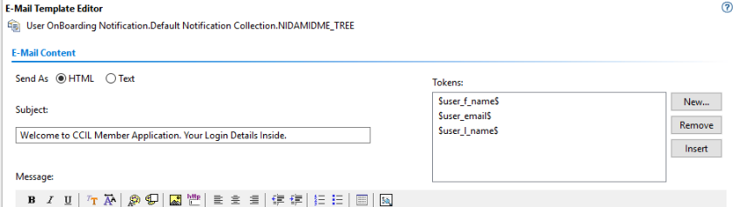  
     1. Mail Body:

<p>Dear $user_f_name$ $user_l_name$,</p><div>

    <p> Welcome to CCIL Member Application.</p>

</div><p>

    <div>

        <p>

        Your account has been successfully created, and you're now ready to access our platform. Below are your login

        credentials:<br/>

            <b>Username: $user_email$</b>

            <br/>

            <b>Password: [Default Password]</b>

        </p>

        <p>

        For security purposes, we recommend changing your password after your initial login. Please follow the steps

        below to log in:

        Go to <a href="https://eidm.ccilindia.com/idmdash">https://eidm.ccilindia.com/idmdash</a>

        Enter your username and the temporary password provided above.

        Once logged in, please setup your secret question and answer for password recovery.<br/>

        </p>

        <p>

            <b>Reset your password:</b>

            <br/>

        If you forgot your password go to url mentioned in point 1 and click on Forgot Password and then reset password

        using secret question and answer setup by you.

        Application Access URL <a href="https://ememberportal.ccilindia.com">https://ememberportal.ccilindia.com</a>

        If you encounter any issues or have any questions, feel free to reach out to idamsupport@ccilindia.co.in

    </p>

    </div>

</p><p>

    <div>

    Regards,

</div>

    <div>

        <div>

            <b>The Clearing Corporation of India Ltd.</b>

        </div>

        <div>

        Mumbai

    </div>

        <div>

        CIN - U65990MH2001PLC131804

    </div>

        <p>(This is an auto-generated email, please do not reply to this email)</p>

    </div>

</p>

1. Design:  
   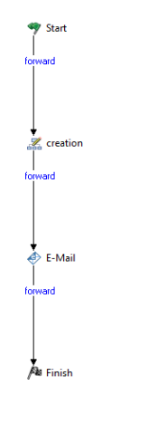
2. Design Form:  
   we created a request_form for creation users through workflow.  
    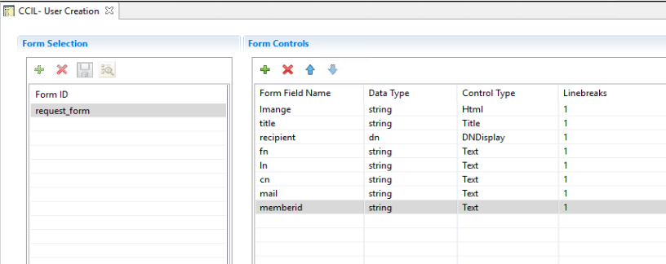
   1. Image:  
      Image filed contains CCIl organization log.

|  |  |  |  |
| --- | --- | --- | --- |
| **Form Field Name** | **Data Type** | **Control Type** | **Line breaks** |
| Imange | String | Html | 1 |

**Properties**:  
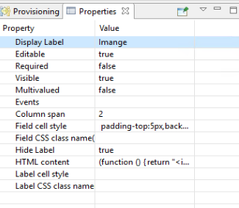

**HTML Content:**

(function () {

    return "<img src=images/ccil.png alt='ccil' width='70' align='center'>";

}

)

    ();

* 1. Title:  
     title field contains form title.

|  |  |  |  |
| --- | --- | --- | --- |
| **Form Field Name** | **Data Type** | **Control Type** | **Line breaks** |
| Title | String | Title | 1 |

**Properties**:  
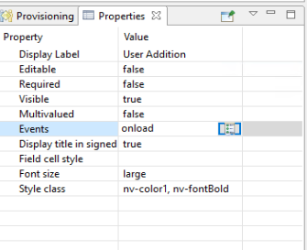

**Events**:  
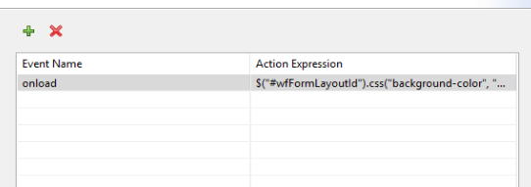

$("#wfFormLayoutId").css("background-color", "#F2F4F4");

* 1. Recipient:  
     recipient filed contains admin user Full Name / First Name – Last name.

|  |  |  |  |
| --- | --- | --- | --- |
| **Form Field Name** | **Data Type** | **Control Type** | **Line breaks** |
| recipient | dn | DNDisplay | 1 |

**Properties**:  
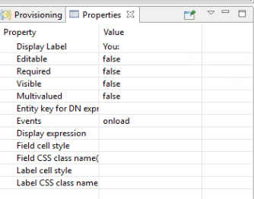  
**Events**:  
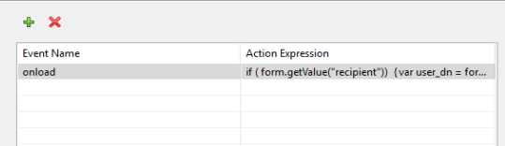

if (form.getValue("recipient")) {

    var user_dn = form.getValue("recipient")

    var ou = IDVault.get(null, user_dn, 'CCILUser', 'Department')

    form.setValues("memberid", ou)

}

* 1. First Name:  
     first name filed contains user first name.

|  |  |  |  |
| --- | --- | --- | --- |
| **Form Field Name** | **Data Type** | **Control Type** | **Line breaks** |
| fn | String | Text | 1 |

**Properties**:  
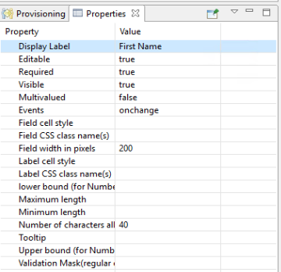  
**Events**:  
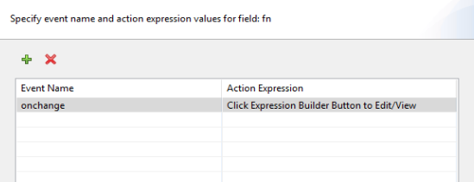

var fin = form.getValues("fn").toString();

var lan = form.getValues("ln").toString();

if (fin != " " && lan != " ") {

    var x = Math.floor(Math.random() * 1000) + 1;

    //alert(x);

    var finn = fin.substring(0, 2).toUpperCase();

    var lann = lan.substring(0, 2).toUpperCase();

    var con = finn + lann + "CCIL" + x;

    //alert(con);

    form.setValues("cn", con);

}

else;

* 1. Last Name:   
     ln filed contains user last name.

|  |  |  |  |
| --- | --- | --- | --- |
| **Form Field Name** | **Data Type** | **Control Type** | **Line breaks** |
| ln | String | Text | 1 |

**Properties**:  
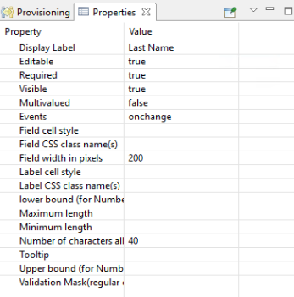  
**Events**:  
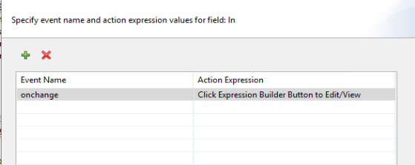

var fin = form.getValues("fn").toString();

var lan = form.getValues("ln").toString();

if (fin != " " && lan != " ") {

    var x = Math.floor(Math.random() * 1000) + 1;

    //alert(x);

    var finn = fin.substring(0, 2).toUpperCase();

    var lann = lan.substring(0, 2).toUpperCase();

    var con = finn + lann + "CCIL" + x;

    //alert(con);

    form.setValues("cn", con);

}

else;

* 1. CN:  
     cn filed contains user common name which is automatically generate by first name first 2 character and last name first 2 character with CCIL and random 3 digits number and it should be unique. e.g., ARNACCIL235

|  |  |  |  |
| --- | --- | --- | --- |
| **Form Field Name** | **Data Type** | **Control Type** | **Line breaks** |
| cn | String | Text | 1 |

**Properties**:  
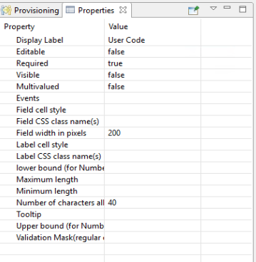

* 1. Email:  
     mail filed contains user Email Id and it should be unique. If existing put existing email showing alert.

|  |  |  |  |
| --- | --- | --- | --- |
| **Form Field Name** | **Data Type** | **Control Type** | **Line breaks** |
| cn | String | Text | 1 |

**Properties**:  
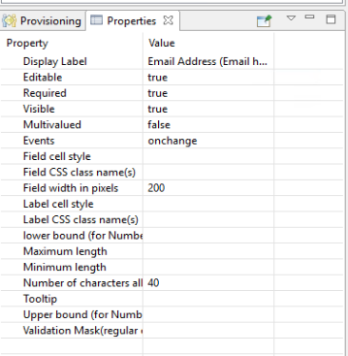  
  
**Events**:  
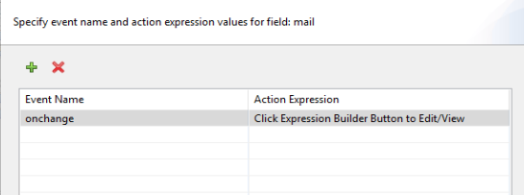

if (form.getValue("mail")) {

    var email = form.getValue("mail")

    var mailRegex = /^[^\s@]+@[^\s@]+\.[^\s@]+$/;

    var b = mailRegex.test(email);

    if (b == false) {

        alert("Please enter a valid email")

        var dig = "";

        form.setValues("mail", dig)

    }

    else {

        var email = form.getValue("mail")

        var email_id = IDVault.globalQuery(null, "CCILUniqueEmail", { "email": email })

        if (email_id[0] == "" || email_id[0] == null) {

            form.setValues("mail", email)

        }

        else {

            alert("The " + email + " is already available, Please Enter Another email ID")

            form.setValues("mail", "")

        }

    }

}

* 1. MemberID:  
     memberid filed contains OU of user. It is automatically populated filed non editable.

|  |  |  |  |
| --- | --- | --- | --- |
| **Form Field Name** | **Data Type** | **Control Type** | **Line breaks** |
| memberid | String | Text | 1 |

**Properties**:  
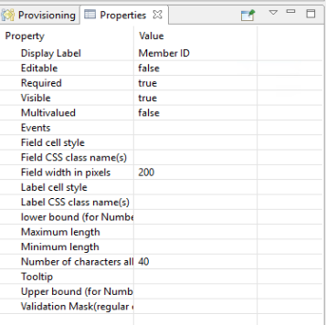

1. Activity:
   1. Start:
      1. Properties:  
         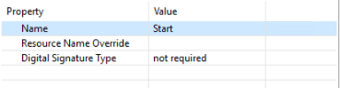
      2. Data Mapping:  
         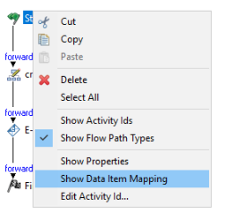  
         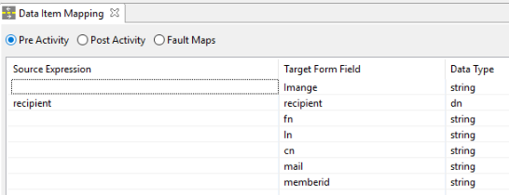  
         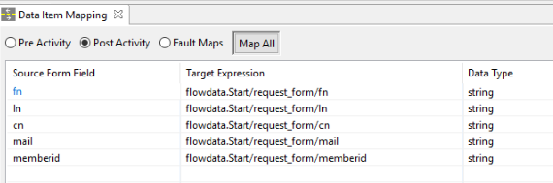
   2. Entity:
      1. Properties:  
         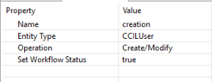
      2. Data Mapping:  
         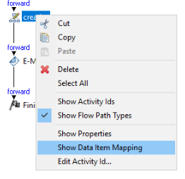  
         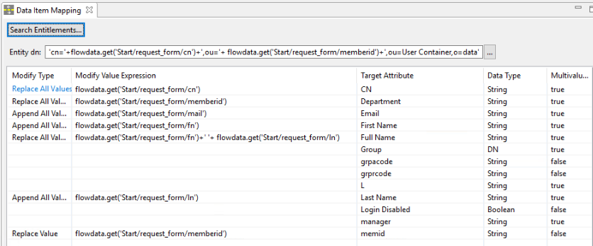
   3. Email:
      1. Properties:  
         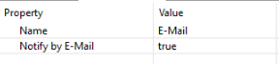
      2. E-Mail Notification:  
         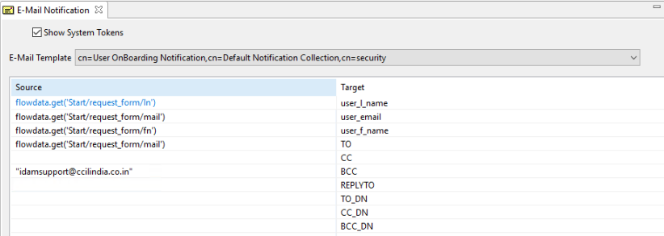
   4. Finish:
      1. Properties:  
         